Image Processor +

User Manual

Contents
Image Processor + 1
User Manual 1
Contents 2
Introduction 3
System Requirements and Installation Instructions 4
Requirements 4
Installation instructions 4
Detailed Instructions on Use 5
Initialising the System 5
Image Handling 6
Loading an image from a file 6
Saving an image to a file 7
Image Manipulation 9
Editing the Red Eye Tolerance 10
Using the Educational Tool 11
Error Reports 12
Image File Handling 12
Tolerance Editing 12
System Errors 12

Introduction
This manual contains installation and execution instructions for the image manipulation software Image Processor +. This will include system requirements and information on what action to take in the event of an error, and how to interpret the outputs of the system. There are also screenshots of the working system so that the instructions on use are clearer. There is no help embedded into the software, so please refer back to this document if assistance on use of the system is ever needed.

System Requirements and Installation Instructions

Requirements
- Windows XP, Windows 7 or higher (not tested for Windows Vista, Windows 98 or below, Linux or Mac)
- 1.05MB of free space on your Hard Disk for the zipped system, and a further 28.8MB of free space for the extracted system, a total of 29.85MB, though the zipped copy can be deleted after installation, but this is not recommended.
- 1.0GHz processor or higher is recommended for reasonable execution times
- At least 256 MB of RAM is recommended for sample Image Processing. More may be needed for very large Images, however most systems will have more than enough memory for most Images.

Installation instructions
  - Either Download a zipped copy of the software or copy a zipped copy of the software from the provided CD or DVD onto your hard disk
  - Extract the zipped folder to a place of your choosing on your file system. To do this in:
    - Windows XP:
      - Open the zipped folder by double clicking on it
      - At the left hand side of windows explorer click “extract all files”
      - This will run the extraction wizard, which will guide you through the extraction process
    - Windows 7
      - Right click on the zipped folder
      - Select “Extract All…”
      - This will run the extraction wizard, which will guide you through the extraction process
n.b. It is recommended you use the “Program Files” folder and name the folder containing the software “Image Processor Plus”
  - Inside your extracted folder there will be a number of sub folders:
    - “Executable” : this folder contains the executable for the software
    - “SampleImages” : this folder contains Images that are designed to be used in conjunction with the Program to display certain algorithms
    - “Source” : If you have a developer copy of the system then the source code will be included as a Turbo Delphi XE project here.
  - Open the folder “Executable” and run “ImageProcessor+.exe” in order to execute the program.
    - n.b. In order to be able to run the program from another area right click on the executable and select “Create Shortcut”, then move the created file to wherever you want to be able to execute it from.

Detailed Instructions on Use
This section of the Manual will guide you through the operations you can perform on the system through step by step instructions and screenshots of sed operations.

Initialising the System
Once installed simply double click on either the executable itself, or a shortcut to it, in order to run it. It is recommended you maximise the window before using the software. When run, the program should look like this:
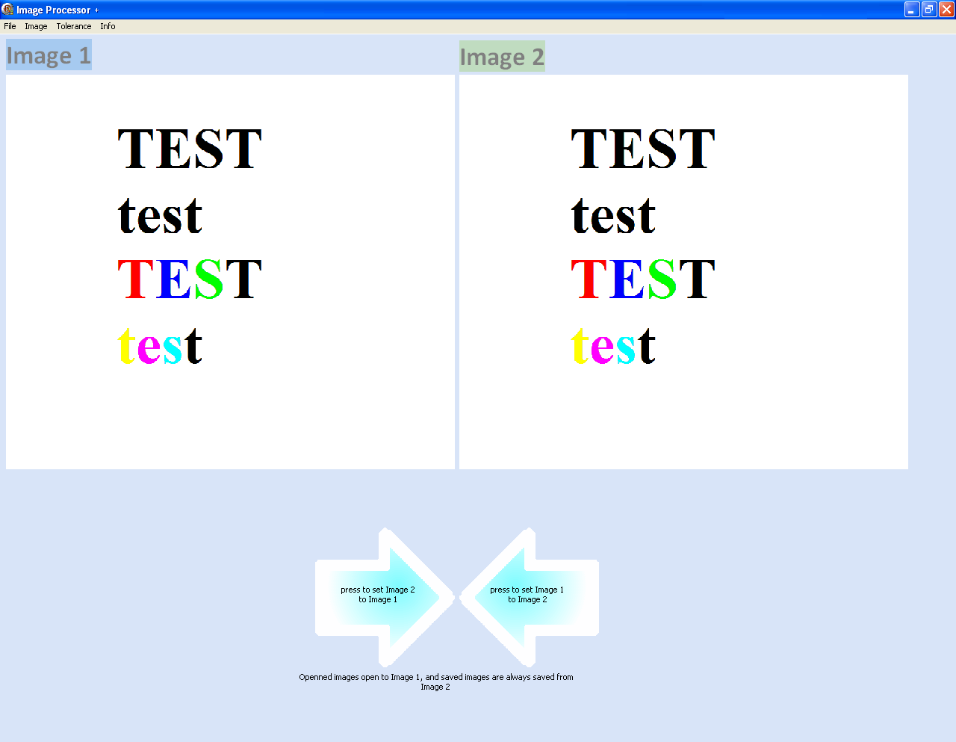

Image Handling

Loading an image from a file
In order to use the sample images or your own images you must first load them into the program from a file:
- Left click ‘File’ on the toolbar at the top left
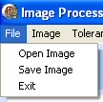
- Left click ‘Open Image’ on the dropdown menu
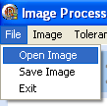
- This will open up a dialogue for file browsing. Navigate to the folder where the image is stored then either double click on the image file or left click on the image file once and then click open it
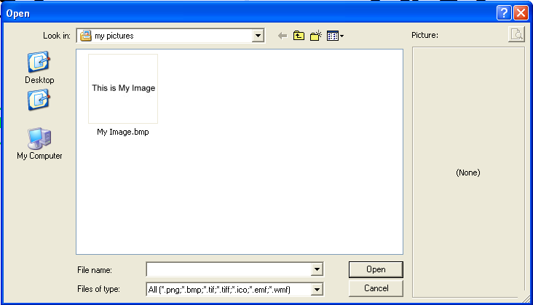
- Your image will now appear in the ‘Image 1’ area of the program on the left for editing
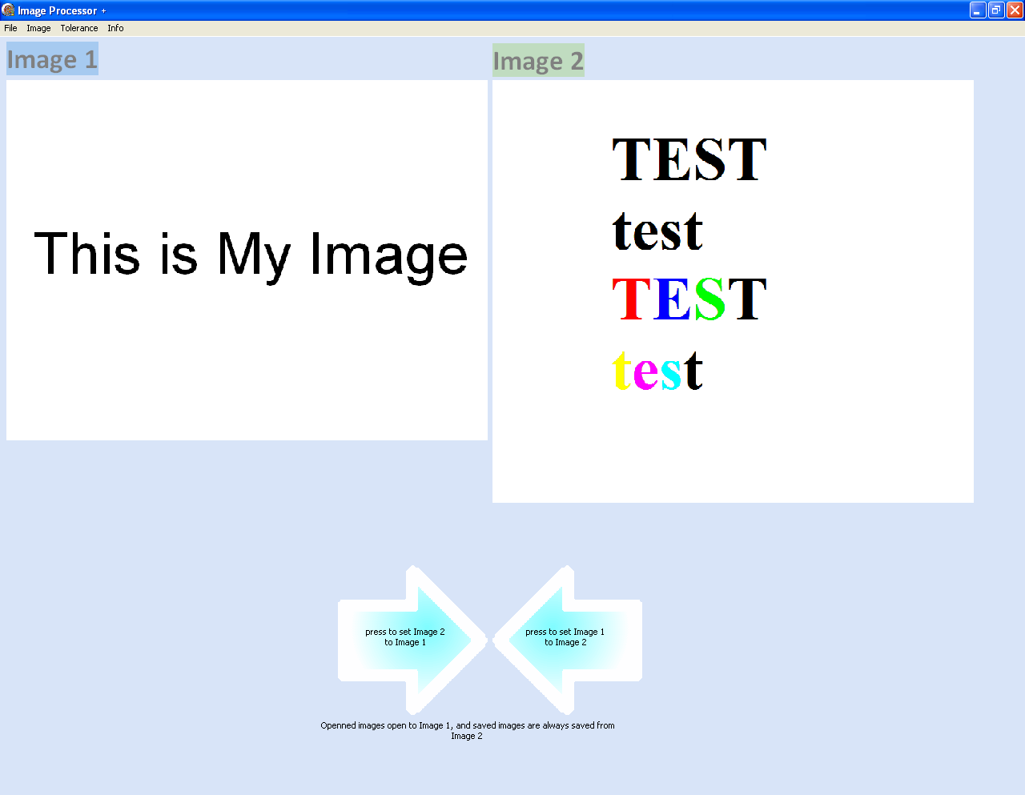

Saving an image to a file
If you wish to save an image for future editing or reference you will need to use the save image functionality (n.b. the ‘Image 2’ on the right hand side of the screen is always the one saved):
- Left click ‘File’ on the toolbar at the top left
- left click on ‘Save Image’ in the dropdown menu
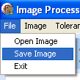
- This will open up a dialogue for file browsing. Navigate to the folder where you wish to save the image. Choose a name for the image in the filed marked ‘File name:’ and left click on sale (n.b. all files are automatically saved as bitmaps using the extension ‘.bmp’; do not attempt to use other file extensions as the image will still be saved as a bitmap)
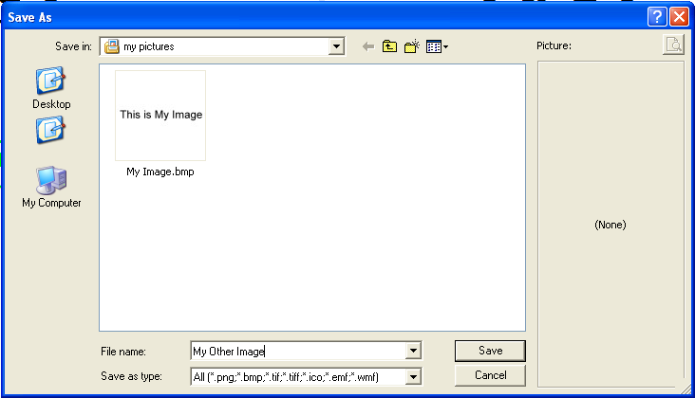
- Your Image will now be saved to the chosen location where you can access it via windows explorer or the ‘Image Processor +’ if you wish to use it again
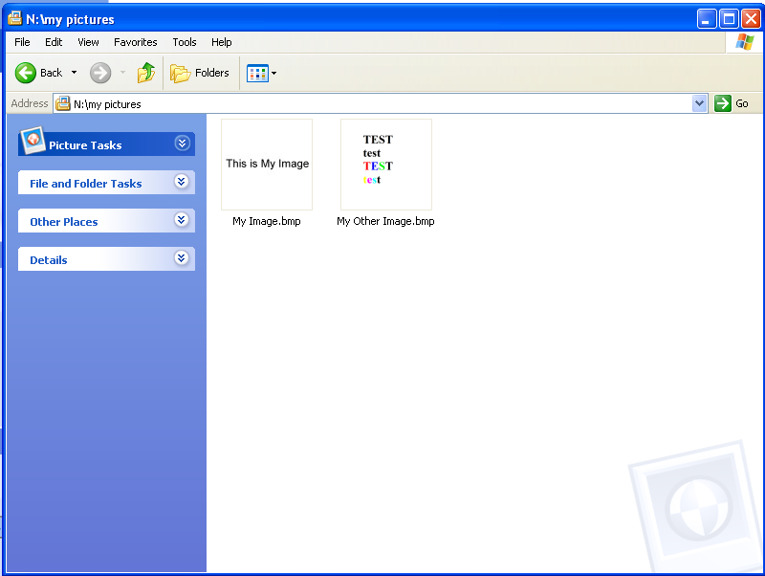

Image Manipulation
The system has an in built library of algorithms it is able to execute. All of these algorithms can be applied to the image with the same method:
- Left click ‘Image’ on the toolbar at the top left
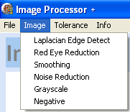
- Use the dropdown menu to select the process you wish to carry out (here ‘Negative’ is chosen)
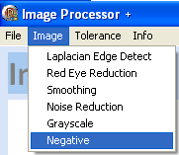
- Left click on this and then wait for the algorithm to be applied (here ‘Negative’ has been applied
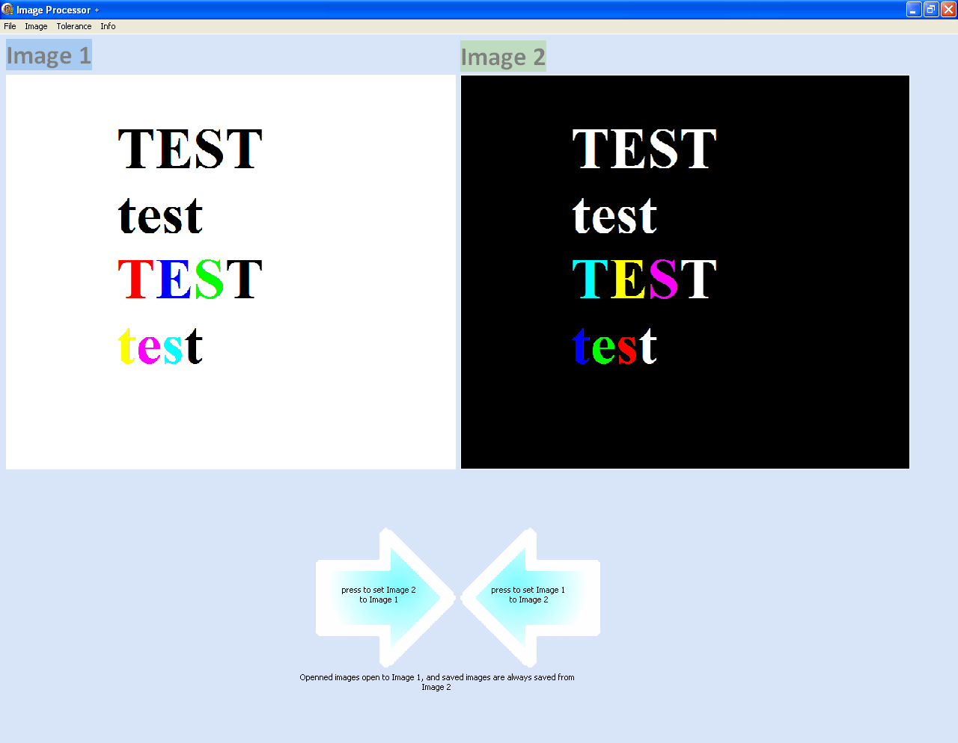

Editing the Red Eye Tolerance
You can change the tolerance of the red eye reduction algorithm (i.e. how ‘red’ a colour has to be to be removed) by using the sub form accessible from the main form:
- Left click ‘Tolerance’ on the toolbar at the top left
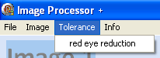
- Select ‘red eye reduction in the drop down menu
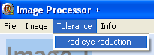
- This will open the red eye tolerance sub form:
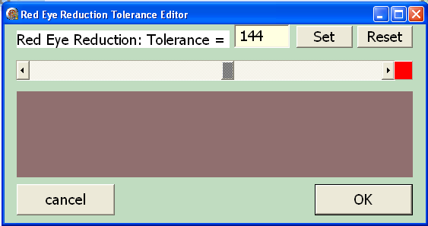
  - To adjust the tolerance either
    - Slide bar left/right to decrease/increase the tolerance respectively
    - Click the left/right arrows to decrease/increase the tolerance respectively
    - Type a value for the tolerance in the box which displays it
  - Click set to update the colour in the box that represents the tolerance
  - Click reset to reset the tolerance to 144 and update the colour box
  - Click the ‘OK’ button to confirm the tolerance change
  - Click the ‘cancel’ button to cancel the tolerance change

Using the Educational Tool
The other sub-form of the program contains information on how the algorithms work for reference for students. To access it:
- Left click ‘Info’ on the toolbar at the top left
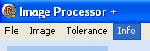
- This will open up the educational form
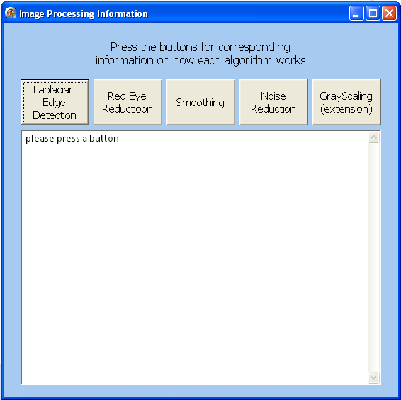
  - To access the Information Left click o the corresponding buttons. If ‘Laplacian Edge Detection’ is pressed for instance, this would be displayed:

Error Reports
When using the system certain user actions may cause error messages related to the program to occur. These will inform you of problems with inputs for instance, or of error within the system. These errors are briefly outlined here:

Image File Handling
  - When attempting to open an image file: “ “filname.png/.gif/.wmv/etc.” is not a valid bitmap “
    - This error occurs when you attempt to open a file which is not a “.bmp” file
    - To fix this, open the image in an editing software such as “MS Paint” and “save as” the file in the format “filename.bmp”, then attempt to open the image in Image Processor +
    - e.g.
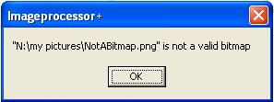

Tolerance Editing
  - When attempting to manually edited the red eye tolerance using the text box: “Invalid Input”
    - This is caused by the value that has been entered into the ext box not being a valid number for the tolerance. Examples of invalid strings include: “foo”, “_32”, “54.6”, “-45”, “$!?”, “FOO”. Valid tolerances lie 0<=tolerance<=255
    - e.g.
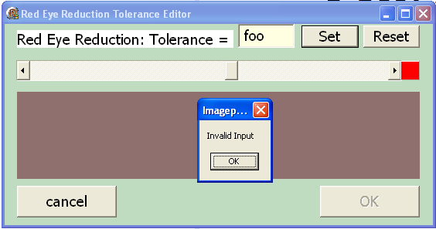

System Errors
Sometimes the system will appear to have issues without an error message provided. These errors are described here:
  - (Windows Error) “ImageProcessor+.exe is not responding” or the program appears unresponsive to the user
    - This kind of error will occur if you are using an Image much larger than the recommended size, or are attempting to run the system on hardware which does not meet the specifications
    - Often the program will recover form this apparent error, but if the program is unresponsive for long periods of time it is recommended you close it, though any unsaved data will be lost
    - If you think the error is not caused because of the above reasons, your copy of the system may be corrupted. In this case it is recommended that you get a fresh copy of the system
    - In Windows XP, this is an example of a use using and image larger than is recommended (note the “(Not Responding)” in the top left, and the blank Image 2, both characteristic of this error):
